The Moon by Mary Barrett

The Moon is really just one size The light grows larger every day
It always stays the same, Exactly as it ought'er,
But here on Earth before our eyes, But logic tells us we must say
We see it wax and wane. What looks like half is quarter.

The new moon we don't see at all, And then there's gibbous on its way
But then there is a sliver, To full, the brightest face,
The crescent moon is what we call Then swiftly it begins to wane
This slice that makes us quiver. 'Til gone without a trace.

These changes happen every night;
Each month we see each phase

The moon intrigues us with its light
It truly does amaze.

Dear God,
It is great the way you always get the stars in the right place. Why can't you do that with the moon?
Jeff (a young child)

Organization of the Moon Project (Worth a total of 75 points)
Part of Project | Point Value | Specific Requirements are on…
Observations and Graph | 25 points | MP–2 through MP–4
Written Paper and illustrations | 40 points | MP–5
Your review of a classmate’s paper | 10 points | MP–5 through MP-8

Information, Tables, and Graphs | Where to find them
Tables in which to record your observations | MP–9 through MP–14
Graph for you to complete | MP–15 through MP–16
Tables of moon facts | MP–17 through MP–21

Purpose: This assignment is designed to give you the opportunity to…
• become intimately familiar with the various changes that the moon goes through each month and season.
• conduct a genuine scientific research project: to make systematic accurate observations and to use those observations to derive scientific conclusions WITHOUT “looking it up” somewhere.
• write a clear, complete, well-illustrated scientific paper that uses evidence and sound logical reasoning to reach a conclusion.

Question to Answer: Which way does the Moon revolve around Earth?
Yes, you can look this up in your textbook, online, or in a wide variety of other sources. The answer is well known. Your job is to prove it, using particular types of observations and a bit of logic.

Observations to Make for Topic #2
Where to Make Your Observations: The best place to make your observations is a large open area such as a sports field or parking lot, but anyplace will do as long as you can see the moon and at least one planet.
Required Number of Observations: You must observe the moon at least 20 times. Each time, a planet should also be visible. You will estimate the angular distance between the moon and that planet. Your observations will be most useful if you make them in sets of several days in a row, preferably at around the same time on each day of each set.
BEGIN YOUR OBSERVATIONS IMMEDIATELY! The sooner you start, the easier it will be. If you have trouble at first, keep trying; it gets easier. Don’t worry if you don’t understand what your observations mean; that’s normal. No scientist ever fully understands his/her observations until s/he has had a chance to analyze a large set of them. Let yourself wonder and not know. Keep making careful observations and keep asking yourself what they are trying to tell you. The answer will come. It may slowly dawn on you or it may suddenly flash into your mind after weeks of frustration. But, if you keep trying, it will definitely come. Here’s a hint: Why do you suppose I am requiring you to make all of your observations in a particular set at the same time of day?
Suggested Times of Observations: Be sure to make each observation when you can see both the moon and a planet. Thus it must be dark or dusk. Do NOT choose this topic if you feel unsafe outdoors in the dark.
Plan your observation times carefully. Sometimes (about half the time), the moon is not out in the evening; instead, it’s out in the morning. On those days, you will have to do your observations in the early morning, before sunrise. To figure out whether you can see the moon in the morning or evening on any particular day, consult the “Moon Facts” tables below.
During February, Mars will be very bright and will be out all night. In the evening, it will be in the east; near midnight, it will be in the south; and in the morning, it will be in the west. Saturn will rise around 8:30 p.m. and will be out the rest of the night; it will be to the left of Mars.
During March, Saturn will be out all night. In the evening, it will be the brightest “star” visible in the east. Mars will still be out in the evening, but will set just after midnight. In the evening, Mars will be high in the southeast.
During April, Venus will become easy to find in the evening; it will be the very bright object in the west. Saturn and Mars will still be around, but harder to find. Jupiter will be visible in the east, just before dawn.
During May, Venus will be very bright in the evening; it will be in the southwest. Jupiter will be quite bright in the morning; it will be in the southeast.

Data to Record: Record your data in the given tables. The first two entries have been completed for you to serve as an example.
1. Record the date and time of each observation. Be sure to include a.m. or p.m. as appropriate.
2. Under “Sketch of Moon,” sketch the moon the way you see it in the sky by blackening the part of the moon that you can NOT see; leave the visible part of the moon white. Be sure to clearly show how the visible portion is “tilted” relative to the horizon (On the data table, imagine the horizon as a horizontal line on the bottom of the page.).
3. Under “Locations of Moon and Planets,” draw and label the moon and whatever planet is visible on the “Celestial Hemisphere” diagram provided. To understand what this diagram is showing, imagine yourself (represented by the stick figure) standing in a large, open field. The sky looks like a huge inverted bowl. The moon, sun, planets and stars look like objects that are moving on the inside surface of this bowl. The moon and planets follow approximately the same path across the sky each day; that path (called the ecliptic) is shown on the diagram as a gray arc that goes from east to west. The moon and any planets (if they are up) should plot somewhere near that arc.
4. Make a rough measurement of the angular distance between the moon and a planet in the sky, using your fists (One “fist” is about 10°.) as shown below. Your lab instructor will demonstrate how to do this. Write this measurement under “Angle between Moon and Planet.”
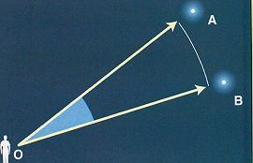 | The angular distance between two objects in the sky is angle AOB.

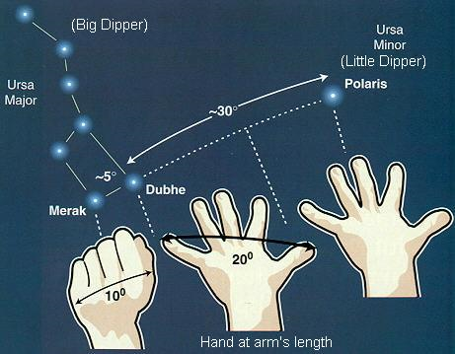 | Estimating angular distance in the sky using your hand held at arm’s length. One fist is about 10°.
Source of diagrams: http://www.geocities.com/angolano/Astronomy/PIinSky.html
5. If it is cloudy out or if you forget to look, make a note of that, but do not sketch the moon unless you actually observe it and do not record any observations that you have not personally made of the real sky (the internet is NOT the real sky). The worst sin that a scientist can commit is to falsify data. Do not commit this sin! Don't laugh–students try it every semester and end up being very disappointed in their moon project grades.
6. Record your observations as neatly as possible. But neatness is much less important than honesty, thoroughness, accuracy and usefulness. For an example of an observation table made by the great scientist, Galileo, see Figure 21.15 on p. 609 in your textbook.
How to Graph
- On the blank graph provided below, plot a point showing the angular distance between the moon and one of the planets.
- Color code your data points as follows:
  - Orange = angles measured relative to Mars
  - Purple = angles measured relative to Saturn
  - Blue = angles measured relative to Venus
  - Green = angles measured relative to Jupiter
- Label the point with an “E” when the moon is east (to the left) of the planet.
- Label the point with a “W” when the moon is west (to the right) of the planet.
Due Date: The observations and graphs will be due BEFORE the complete moon project is due. See your syllabus for the exact date.
What to Hand In: For the “Observations and Graphs” part of the moon project, hand in your original completed moon observation tables and your completed graph(s).
Written Paper: Requirements
- State the direction of the Moon’s revolution around Earth (clockwise or counterclockwise as viewed from above the North Pole).
- Use your data as evidence to support your statement. Clearly explain, in a logical way, how YOUR data leads to your conclusion (i.e. no further supporting evidence is needed, just discuss the significance of your data). Your written explanation should consist of 200-300 well-chosen words (No more; no less).
- Illustrate your paper with at least one clearly labeled diagram.
- All text must be typed. Each page must have a page number.
- Hand-drawn diagrams and graphs are, however, perfectly acceptable.

Peer Review of Your Paper
Before you turn in your paper, you must…
- Have a classmate conduct a peer review of your paper. This classmate must be working on a topic other than yours. After receiving the review, rewrite and improve the paper as needed.
- Conduct a peer review of a classmate’s paper. You will use the rubric on the following page for this purpose; circle the box that applies in each category. In addition, write as many specific suggestions as you can think of to help your classmate improve his/her paper and feel free to mark up your classmate’s work with red (or any color) pen. And remember, “being nice” will not help him/her; constructive criticism will.

Final Submission of Moon Project
Your final submission of your moon project must include (in order)…
- Your observations and graph(s).
- The final drafts of your paper and illustrations.
- The first drafts of your paper and illustrations (the ones reviewed by a classmate).
- The review of your first drafts completed by your classmate.
- A photocopy of the review you did of a classmate’s paper.
Use ordinary paper, stapled together. Simplicity (and conservation of natural resources) is best.

Writer’s Name ____________________________________ Reviewer’s Name_________________________________ ________________________________ | Grading Rubric for the Explanations of the Concepts | Points |  |  |  |  | Multiply raw score by this number to calculate the points earned.
 | Grading Rubric for the Explanations of the Concepts | Excellent (5) | The writer makes a strong irrefutable case for his/her answer, clearly and logically explaining how that answer is supported by the data collected and the graphs plotted. | Diagram is neat, accurate and greatly aids in understanding the text. Caption, labels, and/ or written explanation clearly reveal what diagrams are showing. | The writing is elegant and original; creative analogies clarify concepts. Free of errors. Formatted according to instructions. | Total Points (out of 40):
 | Grading Rubric for the Explanations of the Concepts | Good (4) | Explanation is correct but a little unclear or incomplete. There are a few gaps in logic. The writer assumes a bit too much prior knowledge in the reader. | Diagram contains minor errors or is a bit unclear. Caption, labels or written explanation incomplete. | Text is a bit too wordy or is so concise as to be unclear. Some wording is awkward or contains grammar or spelling errors. Minor formatting errors. | Total Points (out of 40):
 | Grading Rubric for the Explanations of the Concepts | Fair (3) | Explanation is mostly correct. Gaps in logic or invalid logic make the explanation hard to follow. The writer assumes too much prior knowledge in the reader. | Diagram contains major factual errors or is unclear. Caption, labels or written explanation is poor or missing. | Text is quite wordy or unclear. Spelling or grammar errors partially obscure the meaning of the text. | Total Points (out of 40):
 | Grading Rubric for the Explanations of the Concepts | Unacceptable (0-2) | Explanation is incorrect and full of gaps. The logic is invalid and impossible to follow. The writer assumes far too much prior knowledge in reader. | Diagram is missing altogether or is useless because it illustrates something irrelevant to the explanations given in the text. | Poorly worded. Meaning unclear. Full of errors. | Total Points (out of 40):
 | Grading Rubric for the Explanations of the Concepts | Weight¹ | 4 | 2 | 2 | Total Points (out of 40):
 | Grading Rubric for the Explanations of the Concepts | Component | Explanation | Diagram | Grammar, spelling, capitalization, punctuation, etc. | Total Points (out of 40):
Specific Suggestions for Improving the Paper:

Shade in the portion of the moon you CANNOT see. Leave the visible portion white!

Date | Time of Observation (Include am/pm) | Sketch of Moon | Locations of Moon and a Planet | Angle Between Moon and Planet
Aug. 8, 2009 | 10:00 p.m. |  | 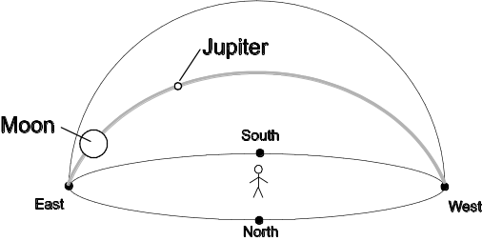 | 35°
Aug. 9, 2009 | 5:15 a.m. |  | 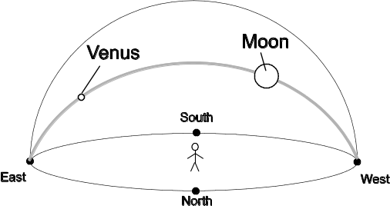 | 100°
 |  |  | 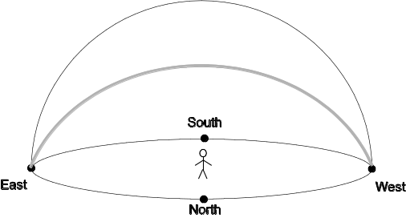

Shade in the portion of the moon you CANNOT see. Leave the visible portion white!

Date | Time of Observation (Include am/pm) | Sketch of Moon | Locations of Moon and a Planet | Angle Between Moon and Planet
Shade in the portion of the moon you CANNOT see. Leave the visible portion white!

Date | Time of Observation (Include am/pm) | Sketch of Moon | Locations of Moon and a Planet | Angle Between Moon and Planet
Shade in the portion of the moon you CANNOT see. Leave the visible portion white!

Date | Time of Observation (Include am/pm) | Sketch of Moon | Locations of Moon and a Planet | Angle Between Moon and Planet
Shade in the portion of the moon you CANNOT see. Leave the visible portion white!

Date | Time of Observation (Include am/pm) | Sketch of Moon | Locations of Moon and a Planet | Angle Between Moon and Planet
Shade in the portion of the moon you CANNOT see. Leave the visible portion white!

Date | Time of Observation (Include am/pm) | Sketch of Moon | Locations of Moon and a Planet | Angle Between Moon and Planet
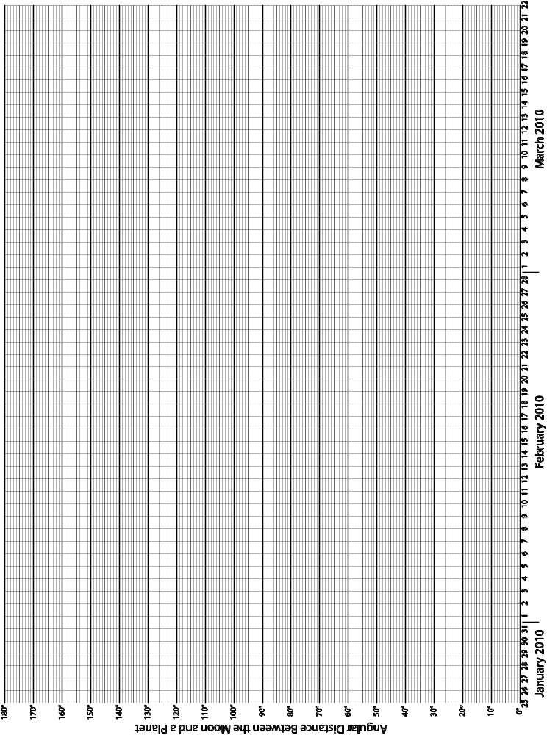
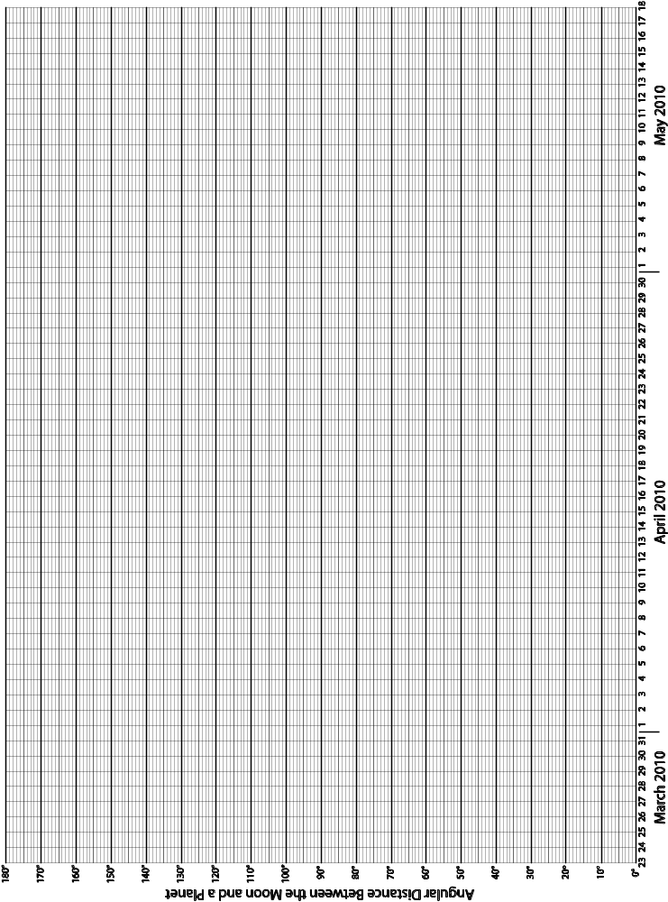
Moon Facts for January, 2010

Date | Day of Week | Time of Sunrise | Time of Sunset | Time of Moonset | Time of Moonrise | Astronomical Place of the moon
1-Jan | Fr. | 7:28 | 4:53 | 8:17 AM | 6:20 PM | Gemini
2-Jan | Sa. | 7:28 | 4:54 | 8:58 AM | 7:39 PM | Cancer
3-Jan | Su. | 7:28 | 4:55 | 9:31 AM | 8:55 PM | Leo
4-Jan | M. | 7:28 | 4:56 | 10:01 AM | 10:08 PM | Leo
5-Jan | Tu. | 7:28 | 4:57 | 10:29 AM | 11:19 PM | Leo
6-Jan | W. | 7:28 | 4:58 | 10:56 AM | ∗ | Virgo
Date | Day of Week | Time of Sunrise | Time of Sunset | Time of Moonrise | Time of Moonset | Astronomical Place of the moon
7-Jan | Th. | 7:28 | 4:59 | 12:28 AM | 11:24 AM | Virgo 
8-Jan | Fr. | 7:28 | 5:00 | 1:35 AM | 11:55 AM | Virgo
9-Jan | Sa. | 7:28 | 5:01 | 2:42 AM | 12:30 PM | Libra
10-Jan | Su. | 7:27 | 5:02 | 3:46 AM | 1:11 PM | Libra
11-Jan | M. | 7:27 | 5:03 | 4:46 AM | 1:57 PM | Scorpius
12-Jan | Tu. | 7:27 | 5:04 | 5:40 AM | 2:50 PM | Ophiuchus
13-Jan | W. | 7:27 | 5:05 | 6:27 AM | 3:47 PM | Sagittarius
14-Jan | Th. | 7:26 | 5:06 | 7:07 AM | 4:46 PM | Sagittarius
15-Jan | Fr. | 7:26 | 5:07 | 7:41AM | 5:47 PM | Sagittarius 
16-Jan | Sa. | 7:25 | 5:08 | 8:10 AM | 6:47 PM | Capricornus
17-Jan | Su. | 7:25 | 5:09 | 8:35 AM | 7:46 PM | Aquarius
18-Jan | M. | 7:25 | 5:10 | 8:59 AM | 8:44 PM | Aquarius
19-Jan | Tu. | 7:24 | 5:11 | 9:21 AM | 9:43 PM | Pisces
20-Jan | W. | 7:24 | 5:13 | 9:43 AM | 10:42 PM | Pisces
21-Jan | Th. | 7:23 | 5:14 | 10:07 AM | 11:44 PM | Pisces
22-Jan | Fr. | 7:22 | 5:15 | 10:33 AM | ∗∗ | Pisces
Date | Day of Week | Time of Sunrise | Time of Sunset | Time of Moonset | Time of Moonrise | Astronomical Place of the moon
23-Jan | Sa. | 7:22 | 5:16 | 12:48 AM | 11:04 AM | Aries 
24-Jan | Su. | 7:21 | 5:17 | 1:54 AM | 11:41 AM | Aries
25-Jan | M. | 7:20 | 5:18 | 3:02 AM | 12:27 PM | Taurus
26-Jan | Tu. | 7:20 | 5:20 | 4:08 AM | 1:24 PM | Taurus
27-Jan | W. | 7:19 | 5:21 | 5:10 AM | 2:32 PM | Taurus
28-Jan | Th. | 7:18 | 5:22 | 6:03 AM | 3:48 PM | Gemini
29-Jan | Fr. | 7:17 | 5:23 | 6:48 AM | 5:08 PM | Gemini
30-Jan | Sa. | 7:16 | 5:24 | 7:26 AM | 6:27 PM | Cancer 
31-Jan | Su. | 7:15 | 5:25 | 7:58 AM | 7:44 PM | Leo

∗ The moon does not rise on this date. It rises early the next day.
∗∗ The moon does not set on this date. It sets early the next day.
Moon Facts for February, 2010

Date | Day of Week | Time of Sunrise | Time of Sunset | Time of Moonset | Time of Moonrise | Astronomical Place of the moon
1-Feb | M. | 7:15 | 5:27 | 8:28 AM | 8:59 PM | Sextans
2-Feb | Tu. | 7:14 | 5:28 | 8:56 AM | 10:11 PM | Virgo
3-Feb | W. | 7:13 | 5:29 | 9:25 AM | 11:22 PM | Virgo
4-Feb | Th. | 7:12 | 5:30 | 9:56 AM | ∗ | Virgo
Date | Day of Week | Time of Sunrise | Time of Sunset | Time of Moonrise | Time of Moonset | Astronomical Place of the moon
5-Feb | Fr. | 7:11 | 5:31 | 12:31 AM | 10:31 AM | Virgo
6-Feb | Sa. | 7:10 | 5:33 | 1:38 AM | 11:10 AM | Libra
7-Feb | Su. | 7:08 | 5:34 | 2:40 AM | 11:55 AM | Scorpius
8-Feb | M. | 7:07 | 5:35 | 3:36 AM | 12:45 PM | Ophiuchus
9-Feb | Tu. | 7:06 | 5:36 | 4:25 AM | 1:41 PM | Sagittarius
10-Feb | W. | 7:05 | 5:37 | 5:07 AM | 2:39 PM | Sagittarius
11-Feb | Th. | 7:04 | 5:39 | 5:43 AM | 3:39 PM | Sagittarius
12-Feb | Fr. | 7:03 | 5:40 | 6:13 AM | 4:39 PM | Capricornus
13-Feb | Sa. | 7:02 | 5:41 | 6:40 AM | 5:39 PM | Aquarius
14-Feb | Su. | 7:00 | 5:42 | 7:04 AM | 6:38 PM | Capricornus
15-Feb | M. | 6:59 | 5:43 | 7:27 AM | 7:36 PM | Aquarius
16-Feb | Tu. | 6:58 | 5:44 | 7:49 AM | 8:36 PM | Pisces
17-Feb | W. | 6:56 | 5:46 | 8:12 AM | 9:36 PM | Pisces
18-Feb | Th. | 6:55 | 5:47 | 8:37 AM | 10:38 PM | Pisces
19-Feb | Fr. | 6:54 | 5:48 | 9:06 AM | 11:43 PM | Pisces
20-Feb | Sa. | 6:52 | 5:49 | 9:40 AM | ∗∗ | Aries
Date | Day of Week | Time of Sunrise | Time of Sunset | Time of Moonset | Time of Moonrise | Astronomical Place of the moon
21-Feb | Su. | 6:51 | 5:50 | 12:48 AM | 10:21 AM | Aries
22-Feb | M. | 6:50 | 5:51 | 1:53 AM | 11:11 AM | Taurus
23-Feb | Tu. | 6:48 | 5:52 | 2:54 AM | 12:12 PM | Taurus
24-Feb | W. | 6:47 | 5:53 | 3:49 AM | 1:21 PM | Gemini
25-Feb | Th. | 6:46 | 5:55 | 4:37 AM | 2:37 PM | Gemini
26-Feb | Fr. | 6:44 | 5:56 | 5:17 AM | 3:55 PM | Cancer
27-Feb | Sa. | 6:43 | 5:57 | 5:52 AM | 5:13 PM | Leo
28-Feb | Su. | 6:41 | 5:58 | 6:24 AM | 6:30 PM | Leo

∗ The moon does not rise on this date. It rises early the next day.
∗∗ The moon does not set on this date. It sets early the next day.
Moon Facts for March, 2010

Date | Day of Week | Time of Sunrise | Time of Sunset | Time of Moonset | Time of Moonrise | Astronomical Place of the moon
1-Mar | M. | 6:40 | 5:59 | 6:53 AM | 7:45 PM | Leo
2-Mar | Tu. | 6:38 | 6:00 | 7:23 AM | 9:00 PM | Virgo
3-Mar | W. | 6:37 | 6:01 | 7:54 AM | 10:12 PM | Virgo
4-Mar | Th. | 6:35 | 6:02 | 8:28 AM | 11:22 PM | Virgo
5-Mar | Fr. | 6:34 | 6:03 | 9:06 AM | ∗ | Libra
Date | Day of Week | Time of Sunrise | Time of Sunset | Time of Moonrise | Time of Moonset | Astronomical Place of the moon
6-Mar | Sa. | 6:32 | 6:04 | 12:28 AM | 9:50 AM | Scorpius
7-Mar | Su. | 6:31 | 6:05 | 1:28 AM | 10:40 AM | Scorpius
8-Mar | M. | 6:29 | 6:06 | 2:21 AM | 11:35 AM | Ophiuchus
9-Mar | Tu. | 6:27 | 6:08 | 3:06 AM | 12:33 PM | Sagittarius
10-Mar | W. | 6:26 | 6:09 | 3:43 AM | 1:32 PM | Sagittarius
11-Mar | Th. | 6:24 | 6:10 | 4:15 AM | 2:32 PM | Capricornus
12-Mar | Fr. | 6:23 | 6:11 | 4:43 AM | 3:31 PM | Capricornus
13-Mar | Sa. | 6:21 | 6:12 | 5:08 AM | 4:30 PM | Capricornus
14-Mar | Su. | 7:20 | 7:13 | 6:32 AM | 6:29 PM | Aquarius
15-Mar | M. | 7:18 | 7:14 | 6:54 AM | 7:29 PM | Pisces
16-Mar | Tu. | 7:16 | 7:15 | 7:18 AM | 8:29 PM | Pisces
17-Mar | W. | 7:15 | 7:16 | 7:42 AM | 9:31 PM | Pisces
18-Mar | Th. | 7:13 | 7:17 | 8:10 AM | 10:35 PM | Pisces
19-Mar | Fr. | 7:12 | 7:18 | 8:43 AM | 11:40 PM | Aries
20-Mar | Sa. | 7:10 | 7:19 | 9:21 AM | ∗∗ | Aries
Date | Day of Week | Time of Sunrise | Time of Sunset | Time of Moonset | Time of Moonrise | Astronomical Place of the moon
21-Mar | Su. | 7:08 | 7:20 | 12:45 AM | 10:08 AM | Taurus
22-Mar | M. | 7:07 | 7:21 | 1:46 AM | 11:04 AM | Taurus
23-Mar | Tu. | 7:05 | 7:22 | 2:42 AM | 12:08 PM | Gemini
24-Mar | W. | 7:04 | 7:23 | 3:30 AM | 1:19 PM | Gemini
25-Mar | Th. | 7:02 | 7:24 | 4:12 AM | 2:33 PM | Cancer
26-Mar | Fr. | 7:00 | 7:25 | 4:48 AM | 3:48 PM | Cancer
27-Mar | Sa. | 6:59 | 7:26 | 5:20 AM | 5:03 PM | Leo
28-Mar | Su. | 6:57 | 7:27 | 5:50 AM | 6:18 PM | Leo
29-Mar | M. | 6:56 | 7:28 | 6:19 AM | 7:32 PM | Virgo
30-Mar | Tu. | 6:54 | 7:29 | 6:49 AM | 8:46 PM | Virgo
31-Mar | W. | 6:52 | 7:30 | 7:22 AM | 9:59 PM | Virgo

∗ The moon does not rise on this date. It rises early the next day.
∗∗ The moon does not set on this date. It sets early the next day.
Moon Facts for April, 2010

Date | Day of Week | Time of Sunrise | Time of Sunset | Time of Moonset | Time of Moonrise | Astronomical Place of the moon
1-Apr | Th. | 6:51 | 7:31 | 8:00 AM | 11:09 PM | Libra
2-Apr | Fr. | 6:49 | 7:32 | 8:42 AM | ∗ | Libra
Date | Day of Week | Time of Sunrise | Time of Sunset | Time of Moonrise | Time of Moonset | Astronomical Place of the moon
3-Apr | Sa. | 6:48 | 7:33 | 12:14 AM | 9:31 AM | Ophiuchus
4-Apr | Su. | 6:46 | 7:34 | 1:11 AM | 10:25 AM | Ophiuchus
5-Apr | M. | 6:44 | 7:35 | 2:00 AM | 11:23 AM | Sagittarius
6-Apr | Tu. | 6:43 | 7:36 | 2:41 AM | 12:23 PM | Sagittarius
7-Apr | W. | 6:41 | 7:37 | 3:15 AM | 1:23 PM | Sagittarius
8-Apr | Th. | 6:40 | 7:38 | 3:45 AM | 2:22 PM | Capricornus
9-Apr | Fr. | 6:38 | 7:39 | 4:11 AM | 3:21 PM | Capricornus
10-Apr | Sa. | 6:37 | 7:40 | 4:35 AM | 4:20 PM | Aquarius
11-Apr | Su. | 6:35 | 7:41 | 4:58 AM | 5:19 PM | Pisces
12-Apr | M. | 6:34 | 7:42 | 5:21 AM | 6:19 PM | Pisces
13-Apr | Tu. | 6:32 | 7:43 | 5:46 AM | 7:21 PM | Pisces
14-Apr | W. | 6:31 | 7:44 | 6:13 AM | 8:26 PM | Pisces
15-Apr | Th. | 6:29 | 7:45 | 6:44 AM | 9:31 PM | Aries
16-Apr | Fr. | 6:28 | 7:46 | 7:21 AM | 10:37 PM | Aries
17-Apr | Sa. | 6:26 | 7:47 | 8:06 AM | 11:40 PM | Taurus
18-Apr | Su. | 6:25 | 7:48 | 9:00 AM | ∗∗ | Taurus
Date | Day of Week | Time of Sunrise | Time of Sunset | Time of Moonset | Time of Moonrise | Astronomical Place of the moon
19-Apr | M. | 6:23 | 7:49 | 12:37 AM | 10:02 AM | Taurus
20-Apr | Tu. | 6:22 | 7:50 | 1:28 AM | 11:10 AM | Gemini
21-Apr | W. | 6:20 | 7:51 | 2:11 AM | 12:21 PM | Gemini
22-Apr | Th. | 6:19 | 7:52 | 2:48 AM | 1:34 PM | Cancer
23-Apr | Fr. | 6:18 | 7:53 | 3:20 AM | 2:47 PM | Leo
24-Apr | Sa. | 6:16 | 7:54 | 3:49 AM | 3:59 PM | Sextans
25-Apr | Su. | 6:15 | 7:55 | 4:18 AM | 5:11 PM | Leo
26-Apr | M. | 6:14 | 7:56 | 4:47 AM | 6:23 PM | Virgo
27-Apr | Tu. | 6:12 | 7:57 | 5:18 AM | 7:36 PM | Virgo
28-Apr | W. | 6:11 | 7:58 | 5:53 AM | 8:47 PM | Virgo
29-Apr | Th. | 6:10 | 7:59 | 6:34 AM | 9:55 PM | Libra
30-Apr | Fr. | 6:08 | 8:00 | 7:20 AM | 10:56 PM | Scorpius

∗ The moon does not rise on this date. It rises early the next day.
∗∗ The moon does not set on this date. It sets early the next day.
Moon Facts for May, 2010

Date | Day of Week | Time of Sunrise | Time of Sunset | Time of Moonset | Time of Moonrise | Astronomical Place of the moon
1-May | Sa. | 6:07 | 8:01 | 8:13 AM | 11:50 PM | Ophiuchus
2-May | Su. | 6:06 | 8:02 | 9:10 AM | ∗ | Sagittarius
Date | Day of Week | Time of Sunrise | Time of Sunset | Time of Moonrise | Time of Moonset | Astronomical Place of the moon
3-May | M. | 6:05 | 8:03 | 12:35 AM | 10:10 AM | Sagittarius
4-May | Tu. | 6:04 | 8:04 | 1:13 AM | 11:11 AM | Sagittarius
5-May | W. | 6:02 | 8:05 | 1:44 AM | 12:11 PM | Capricornus
6-May | Th. | 6:01 | 8:06 | 2:12 AM | 1:11 PM | Aquarius
7-May | Fr. | 6:00 | 8:07 | 2:37 AM | 2:09 PM | Aquarius
8-May | Sa. | 5:59 | 8:08 | 3:00 AM | 3:08 PM | Aquarius
9-May | Su. | 5:58 | 8:09 | 3:23 AM | 4:07 PM | Pisces
10-May | M. | 5:57 | 8:10 | 3:47 AM | 5:08 PM | Pisces
11-May | Tu. | 5:56 | 8:11 | 4:13 AM | 6:12 PM | Pisces
12-May | W. | 5:55 | 8:12 | 4:43 AM | 7:17 PM | Aries
13-May | Th. | 5:54 | 8:13 | 5:19 AM | 8:24 PM | Aries
14-May | Fr. | 5:53 | 8:14 | 6:01 AM | 9:30 PM | Taurus
15-May | Sa. | 5:52 | 8:15 | 6:53 AM | 10:31 PM | Taurus
16-May | Su. | 5:51 | 8:16 | 7:54 AM | 11:24 PM | Taurus
17-May | M. | 5:50 | 8:17 | 9:01 AM | ∗∗ | Gemini
Date | Day of Week | Time of Sunrise | Time of Sunset | Time of Moonset | Time of Moonrise | Astronomical Place of the moon
18-May | Tu. | 5:49 | 8:17 | 12:10 AM | 10:13 AM | Gemini
19-May | W. | 5:49 | 8:18 | 12:49 AM | 11:25 AM | Cancer
20-May | Th. | 5:48 | 8:19 | 1:22 AM | 12:38 PM | Leo
21-May | Fr. | 5:47 | 8:20 | 1:52 AM | 1:49 PM | Sextans
22-May | Sa. | 5:46 | 8:21 | 2:20 AM | 2:59 PM | Leo
23-May | Su. | 5:46 | 8:22 | 2:48 AM | 4:09 PM | Virgo
24-May | M. | 5:45 | 8:23 | 3:18 AM | 5:20 PM | Virgo
25-May | Tu. | 5:44 | 8:23 | 3:50 AM | 6:30 PM | Virgo
26-May | W. | 5:44 | 8:24 | 4:28 AM | 7:38 PM | Libra
27-May | Th. | 5:43 | 8:25 | 5:11 AM | 8:42 PM | Libra
28-May | Fr. | 5:43 | 8:26 | 6:01 AM | 9:39 PM | Ophiuchus
29-May | Sa. | 5:42 | 8:27 | 6:57 AM | 10:28 PM | Ophiuchus
30-May | Su. | 5:42 | 8:27 | 7:57 AM | 11:09 PM | Sagittarius
31-May | M. | 5:41 | 8:28 | 8:58 AM | 11:43 PM | Sagittarius

∗ The moon does not rise on this date. It rises early the next day.
∗∗ The moon does not set on this date. It sets early the next day.

Mary Barrett is a school teacher in Berkeley, CA. This poem appeared in the Fall/Winter 1999 GEMS Network News. If you plan to teach elementary or junior high school, check out all the wonderful GEMS (Great Explorations in Math and Science) K–8 teacher’s guides in math and science at http://www.lhs.berkeley.edu/gems/gems.html.

