The Moon by Mary Barrett

The Moon is really just one size The light grows larger every day
It always stays the same, Exactly as it ought'er,
But here on Earth before our eyes, But logic tells us we must say
We see it wax and wane. What looks like half is quarter.

The new moon we don't see at all, And then there's gibbous on its way
But then there is a sliver, To full, the brightest face,
The crescent moon is what we call Then swiftly it begins to wane
This slice that makes us quiver. 'Til gone without a trace.

These changes happen every night;
Each month we see each phase

The moon intrigues us with its light
It truly does amaze.

Dear God,
It is great the way you always get the stars in the right place. Why can't you do that with the moon?
Jeff (a young child)

Organization of the Moon Project (Worth a total of 85 points)
Part of Project | Point Value | Specific Requirements are on…
Observations and Graph | 25 points | p. 2–5
Written Paper and illustrations | 50 points | p. 5–12
Your review of a classmate’s paper | 10 points | p. 12–14

Information, Tables, and Graphs | Where to find them
Tables in which to record your observations | p. 15–20
Graph for you to complete | p. 21–22
Tables of moon facts | p. 23–27

Purpose: This assignment is designed to give you the opportunity to…
• become intimately familiar with the various changes that the moon goes through each month and season.
• conduct a genuine scientific research project: to make systematic accurate observations and to use those observations to derive scientific conclusions WITHOUT “looking it up” somewhere.
• write a clear, complete, well-illustrated scientific paper that uses evidence and sound logical reasoning to reach a conclusion.

Question to Answer: Which way does the Moon revolve around Earth?
Yes, you can look this up in your textbook, online, or in a wide variety of other sources. The answer is well known. Your job is to prove it, using particular types of observations and a bit of logic.

Observations to Make for Topic #3
Where to Make Your Observations: The best place to make your observations is a large open area such as a sports field or parking lot.
Required Number of Observations: You must observe the moon at least 20 times during the day (Yes, really—the moon is often up during the day.) and measure the angular distance between the moon and the sun. Your observations will be most useful if you make them in sets of several days in a row, preferably at around the same time on each day of each set.
BEGIN YOUR OBSERVATIONS IMMEDIATELY! The sooner you start, the easier it will be. If you have trouble at first, keep trying; it gets easier. Don’t worry if you don’t understand what your observations mean; that’s normal. No scientist ever fully understands his/her observations until s/he has had a chance to analyze a large set of them. Let yourself wonder and not know. Keep making careful observations and keep asking yourself what they are trying to tell you. The answer will come. It may slowly dawn on you or it may suddenly flash into your mind after weeks of frustration. But, if you keep trying, it will definitely come. Here’s a hint: Why do you suppose I am requiring you to repeatedly measure the angle between the moon and the sun? What would you expect to see if the moon revolved around Earth clockwise? Counterclockwise?

Suggested Times of Observations: Be sure to make each observation when the moon and sun are both out. Just before sunset or just after sunrise are best because it’s easier to find the moon when the sun is not too bright. Moonrise and moonset times vary greatly. Use the “Moon Facts” tables to figure out when the moon will be out during the day and when the sun rises and sets each day.

Data to Record: Record your data in the given tables. The first entry has been completed for you to serve as an example.
1. Record the date and time of each observation. Be sure to include a.m. or p.m. as appropriate.
2. Under “Sketch of Moon,” sketch the moon the way you see it in the sky by blackening the part of the moon that you can NOT see; leave the visible part of the moon white. Be sure to clearly show how the visible portion is “tilted” relative to the horizon (On the data table, imagine the horizon as a horizontal line on the bottom of the page.).
3. Under “Locations of Moon and Sun,” draw and label the sun and moon on the “Celestial Hemisphere” diagram provided. To understand what this diagram is showing, imagine yourself (represented by the stick figure) standing in a large, open field. The sky looks like a huge inverted bowl. The moon, sun, planets and stars look like objects that are moving on the inside surface of this bowl. The sun and moon follow approximately the same path across the sky each day; that path (called the ecliptic) is shown on the diagram as a gray arc that goes from east to west. The moon and sun (if they are up) should plot somewhere near that arc.
4. Make a rough measurement of the angular distance between the sun and the moon in the sky, using your fists (One “fist” is about 10°.) as shown below. Your lab instructor will demonstrate how to do this. Write this measurement under “Angle between Moon and Sun.”
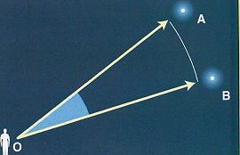 | The angular distance between two objects in the sky is angle AOB.

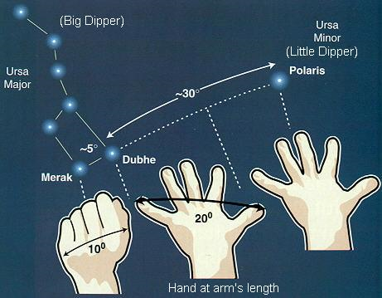 | Estimating angular distance in the sky using your hand held at arm’s length.
Source of diagrams: http://www.geocities.com/angolano/Astronomy/PIinSky.html
5. If it is cloudy out or if you forget to look, make a note of that, but do not sketch the moon unless you actually observe it and do not record any observations that you have not personally made of the real sky (the internet is NOT the real sky). The worst sin that a scientist can commit is to falsify data. Do not commit this sin! Don't laugh–students try it every semester and end up being very disappointed in their moon project grades.
6. Record your observations as neatly as possible. But neatness is much less important than honesty, thoroughness, accuracy and usefulness. For an example of an observation table made by the great scientist, Galileo, see Figure 21.15 on p. 609 in your textbook.
What to Graph
- On the blank graph provided below, plot a point showing the angular distance between the moon and the sun for each of your observations.
- Color code your data points as follows:
  - Red = angles measured when the moon is east (to the left) of the sun
  - Blue = angles measured when the moon is west (to the right) of the sun

Due Date: The observations and graphs will be due BEFORE the complete moon project is due. See your syllabus for the exact date.
What to Hand In: For the “Observations and Graphs” part of the moon project, hand in your original completed moon observation tables and your completed graph(s).
Requirements for the Written Paper

You will write this paper as if it were addressed to a group of early 17th century scientists in England (freshly released from the shackles of belief in an Earth-centered universe). A paper has recently been presented by Namffuak Krekyb Nna, asserting that the moon revolves around Earth from east to west (clockwise as viewed from above the North Pole). This paper is on pages 5-8. Your job is to either support or refute Nna’s assertion, using your data as evidence. Use Nna’s paper as a model for how to write your own; notice especially how she describes the reasoning that lead her from her data to her conclusion.

In your paper, you must…
- State the direction of the Moon’s revolution around Earth (clockwise or counterclockwise as viewed from above the North Pole).
- Clearly explain, in a logical way, the reasoning you used to get from YOUR topic-specific observations and graphs to your conclusion. Read the boldface phrase again; I cannot emphasize this enough. Merely describing your data and then stating your conclusion is insufficient.
Please note: We will be doing a lab activity on the phases of the moon and eclipses. This lab involves figuring out which way the moon revolves around Earth by using your observations of which side of the moon is lit during the waxing and waning moon phases. DO NOT focus on this particular type of evidence in your paper; we do that in class. We want you to go beyond what we do in class and use your topic-specific data to support a conclusion.
- If you refute Nna, you must also explain what’s wrong with her data and/or reasoning.
- Explain what makes the moon rise and set and why this apparent motion of the moon confuses our perception of the direction of the moon’s revolution.
- Illustrate your paper with at least one well-designed clearly annotated diagram that shows how your topic-specific evidence supports your conclusion.
- Include all of your observations and graphs in your paper. Specifically refer to these in your paper.
- All text must be typed. Each page must have a page number.
- Hand-drawn diagrams and graphs are, however, perfectly acceptable.

The Paper You Must Support or Refute

Note: This paper meets all of the writing requirements of this project. Use it as a guide for writing your own paper (but don’t assume that Nna is correct).

Irrefutable Proof that the Moon Revolves Around Earth from East to West
by Namffuak Krekyb Nna, D.hP., Presented in London on March 1, 1611

Introduction
I am presenting this paper to settle once and for all the ongoing dispute that has been raging in our midst about the direction of the Moon's revolution around Earth. I very meticulously and carefully observed the moon every day for a full 29 days and 29 nights between January 4 and February 1 in the Year of Our Lord 1611. These observations lead me to what I believe are irrefutable conclusions about (1) the direction of the revolution of the moon around Earth and (2) the period of its orbit.

Observations
In order to determine the direction and period of the moon's revolution around Earth, I observed and recorded the time and location of the moon (recorded as a compass direction)at moonrise, at its highest point, and at moonset. I did this every day between January 4th and February 1st (See Figure 1 for example data). During this period of time, each rising of the moon occurred within 20° of east (090° ± 20°), sometimes a little south of east, sometimes a little north of east. The moon then traveled gradually westward, following an arc across the southern sky (See Figure 2). This journey always culminated in the setting of the moon, generally in the west (270° ± 20°), sometimes a little south of west, sometimes a little north of west. This journey took anywhere between 9 hours, 24 minutes and 15 hours, 29 minutes (see Table 1 for daily figures); the average duration of this journey was 12 hours, 14 minutes. My data are summarized in Table 1.
Table 1: Location and Time of Moon Rise and Moon Set
Date | Moon Rise |  | Compass Direction of Moon at Moon Rise | Moon Set |  | Compass Direction of Moon at Moon Set | # of Hours the Moon is Up | Elapsed Time from Moon rise to Moon rise
4-Jan | 7:40 | AM | 105° | 5:35 | PM | 255° | 9:55
5-Jan | 8:16 | AM | 102° | 6:38 | PM | 258° | 10:22 | 24:36
6-Jan | 8:47 | AM | 098° | 7:39 | PM | 261° | 10:52 | 24:31
7-Jan | 9:14 | AM | 095° | 8:39 | PM | 264° | 11:25 | 24:27
8-Jan | 9:39 | AM | 092° | 9:37 | PM | 267° | 11:58 | 24:25
9-Jan | 10:03 | AM | 088° | 10:34 | PM | 270° | 12:31 | 24:24
10-Jan | 10:27 | AM | 085° | 11:32 | PM | 273° | 13:05 | 24:24
11-Jan | 10:51 | AM | 083° | ** |  | 276° |  | 24:24
12-Jan | 11:18 | AM | 080° | 12:31 | AM | 279° | 13:40 | 24:27
13-Jan | 11:49 | AM | 079° | 1:31 | AM | 282° | 14:13 | 24:31
14-Jan | 12:26 | PM | 076° | 2:32 | AM | 285° | 14:43 | 24:37
15-Jan | 1:10 | PM | 073° | 3:34 | AM | 288° | 15:08 | 24:34
16-Jan | 2:02 | PM | 070° | 4:34 | AM | 289° | 15:24 | 24:52
17-Jan | 3:04 | PM | 073° | 5:31 | AM | 290° | 15:29 | 25:02
18-Jan | 4:13 | PM | 076° | 6:22 | AM | 285° | 15:18 | 25:09
19-Jan | 5:26 | PM | 079° | 7:07 | AM | 282° | 14:54 | 25:13
20-Jan | 6:41 | PM | 082° | 7:46 | AM | 279° | 14:20 | 25:15
21-Jan | 7:55 | PM | 085° | 8:20 | AM | 276° | 13:39 | 25:14
22-Jan | 9:09 | PM | 088° | 8:51 | AM | 273° | 12:56 | 25:14
23-Jan | 10:22 | PM | 091° | 9:22 | AM | 270° | 12:13 | 25:13
24-Jan | 11:34 | PM | 093° | 9:52 | AM | 267° | 11:30 | 25:12
25-Jan | * |  | 095° | 10:25 | AM | 264° | 10:51
26-Jan | 12:45 | AM | 098° | 11:02 | AM | 261° | 10:17 | 25:11
27-Jan | 1:54 | AM | 101° | 11:43 | AM | 258° | 9:49 | 25:09
28-Jan | 3:00 | AM | 103° | 12:31 | PM | 255° | 9:31 | 25:06
29-Jan | 4:00 | AM | 106° | 1:24 | PM | 250° | 9:24 | 25:00
30-Jan | 4:53 | AM | 103° | 2:23 | PM | 255° | 9:30 | 24:53
31-Jan | 5:38 | AM | 101° | 3:24 | PM | 258° | 9:46 | 24:45
1-Feb | 6:16 | AM | 098° | 4:26 | PM | 261° | 10:10 | 24:38
 |  |  |  |  |  | Averages | 12:14 | 24:50
*The moon didn’t rise on this date. It rose early the next day.
**The moon didn’t set on this date. It set early the next day.

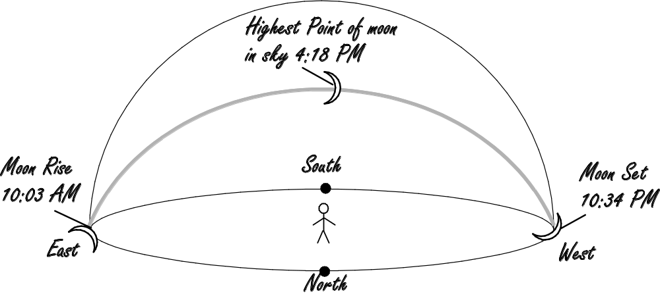
Figure 1: Example of the data collected. This example shows the location of moon and the time of day at moonrise, at the moon’s highest point in the sky, and at moonset on January 9, 1611.

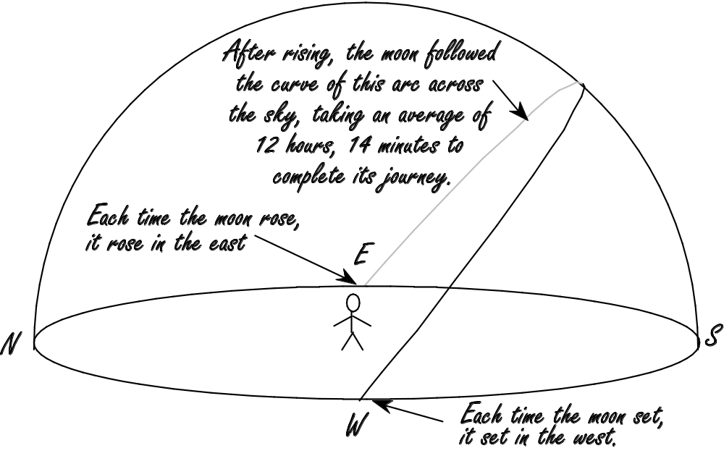
Figure 2: Diagram showing the daily path followed by the moon on its journey between moonrise and moonset.
Interpretation
I interpret this consistent gradual east-to-west movement of the moon across the sky as the revolution of the moon around Earth. I assert that every time the moon set in the west, it did not in fact disappear, but, rather, continued its journey around Earth, out of sight from my location in England (but visible in the American colonies and over the Pacific Ocean). When it had traveled far enough around Earth to once again be visible from England, those of us in England could then see the moon rising in the east (See Figure 3 for an illustration of this phenomenon).

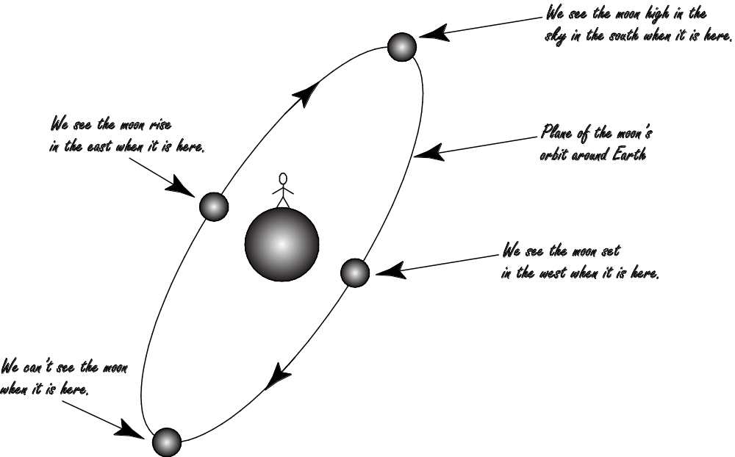

Figure 3: Diagram showing how the clockwise orbit of the moon around Earth is manifested as the moon rising in the east and setting in the west, as seen by a person in England.

The observations of the times of moonrise provide the evidence needed to derive the period of the moon's revolution. Table 1 shows the time elapsed between successive moonrise events between January 4 and February 1, 1611. The elapsed time between each successive pair of moonrise events varied between 24 hours, 24 minutes and 25 hours, 15 minutes. The average time interval between successive moonrise events was 24 hours, 50 minutes. My interpretation of these data is that the time between one moonrise and the next represents the time it took for the moon to complete one 360° revolution around the Earth (see Figure 3).

Conclusion
In conclusion, I interpret my observations to demonstrate that the moon revolves around the Earth from east to west and that its period of revolution averages 24 hours, 50 minutes. I now welcome the opportunity to argue my case with any person who has an alternative explanation for these observations.

Peer Reviews
Before you turn in your paper, you must…
- Have a classmate conduct a peer review of your paper. This classmate must be working on a topic other than yours. After receiving the review, rewrite and improve the paper as needed.
- Conduct a peer review of a classmate’s paper. You will use the rubric on the following page for this purpose; circle the box that applies in each category. In addition, write as many specific suggestions as you can think of to help your classmate improve his/her paper and feel free to mark up your classmate’s work with red (or any color) pen. And remember, “being nice” will not help him/her; specific constructive criticism will. Also, this review is worth points, so before you give it to your classmate, be sure to photocopy it so you can turn it in for credit.

Final Submission of Moon Project
Your final submission of your moon project must include (in order)…
- Your observations and graph(s).
- The final drafts of your paper and illustrations.
- The first drafts of your paper and illustrations (the ones reviewed by a classmate).
- The review of your first drafts completed by your classmate.
- Very Important! A photocopy of the review you did of a classmate’s paper—don’t count on your classmate to include your review with his/her final submission of the moon project.
Use ordinary paper, stapled together. Be sure to make it possible for the reader to view any fold-out graphs or other illustrations without undoing the staples.

Writer’s Name ____________________________________ Reviewer’s Name_________________________________ ________________________________ | Grading Rubric for the Explanations of the Concepts | Points |  |  |  |  | Multiply raw score by this number to calculate the points earned.
 | Grading Rubric for the Explanations of the Concepts | Excellent (5) | The writer makes a strong irrefutable case for his/her answer, clearly and logically explaining how that answer is supported by the data collected and the graphs plotted. | Diagram is neat, accurate and greatly aids in understanding the text. Caption, labels, and/ or written explanation clearly reveal what diagrams are showing. | The writing is elegant and original; creative analogies clarify concepts. Free of errors. Formatted according to instructions. | Total Points (out of 50):
 | Grading Rubric for the Explanations of the Concepts | Good (4) | Explanation is correct but a little unclear or incomplete. There are a few gaps in logic. The writer assumes a bit too much prior knowledge in the reader. | Diagram contains minor errors or is a bit unclear. Caption, labels or written explanation incomplete. | Text is a bit too wordy or is so concise as to be unclear. Some wording is awkward or contains grammar or spelling errors. Minor formatting errors. | Total Points (out of 50):
 | Grading Rubric for the Explanations of the Concepts | Fair (3) | Explanation is mostly correct. Gaps in logic or invalid logic make the explanation hard to follow. The writer assumes too much prior knowledge in the reader. | Diagram contains major factual errors or is unclear. Caption, labels or written explanation is poor or missing. | Text is quite wordy or unclear. Spelling or grammar errors partially obscure the meaning of the text. | Total Points (out of 50):
 | Grading Rubric for the Explanations of the Concepts | Unacceptable (0-2) | Explanation is incorrect and full of gaps. The logic is invalid and impossible to follow. The writer assumes far too much prior knowledge in reader. | Diagram is missing altogether or is useless because it illustrates something irrelevant to the explanations given in the text. | Poorly worded. Meaning unclear. Full of errors. | Total Points (out of 50):
 | Grading Rubric for the Explanations of the Concepts | Weight¹ | 5 | 3 | 2 | Total Points (out of 50):
 | Grading Rubric for the Explanations of the Concepts | Component | Explanation | Diagram | Grammar, spelling, capitalization, punctuation, etc. | Total Points (out of 50):
Specific Suggestions for Improving the Paper:

Shade in the portion of the moon you CANNOT see. Leave the visible portion white!

Date | Time of Observation (Include am/pm) | Sketch of Moon | Locations of Moon and Sun | Angle Between Moon and Sun
Aug. 8, 2009 | 7:15 a.m. | 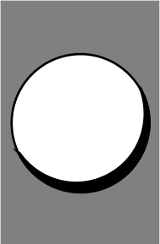 | 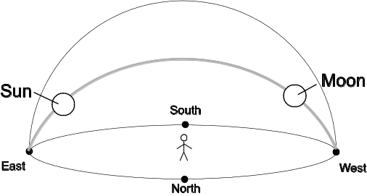 | 130°
 |  | 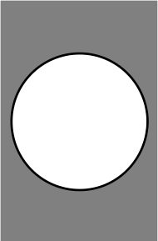 | 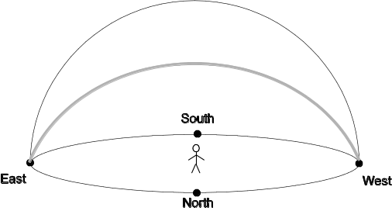

Shade in the portion of the moon you CANNOT see. Leave the visible portion white!

Date | Time of Observation (Include am/pm) | Sketch of Moon | Locations of Moon and Sun | Angle Between Moon and Sun

Shade in the portion of the moon you CANNOT see. Leave the visible portion white!

Date | Time of Observation (Include am/pm) | Sketch of Moon | Locations of Moon and Sun | Angle Between Moon and Sun

Shade in the portion of the moon you CANNOT see. Leave the visible portion white!

Date | Time of Observation (Include am/pm) | Sketch of Moon | Locations of Moon and Sun | Angle Between Moon and Sun

Shade in the portion of the moon you CANNOT see. Leave the visible portion white!

Date | Time of Observation (Include am/pm) | Sketch of Moon | Locations of Moon and Sun | Angle Between Moon and Sun

Shade in the portion of the moon you CANNOT see. Leave the visible portion white!

Date | Time of Observation (Include am/pm) | Sketch of Moon | Locations of Moon and Sun | Angle Between Moon and Sun

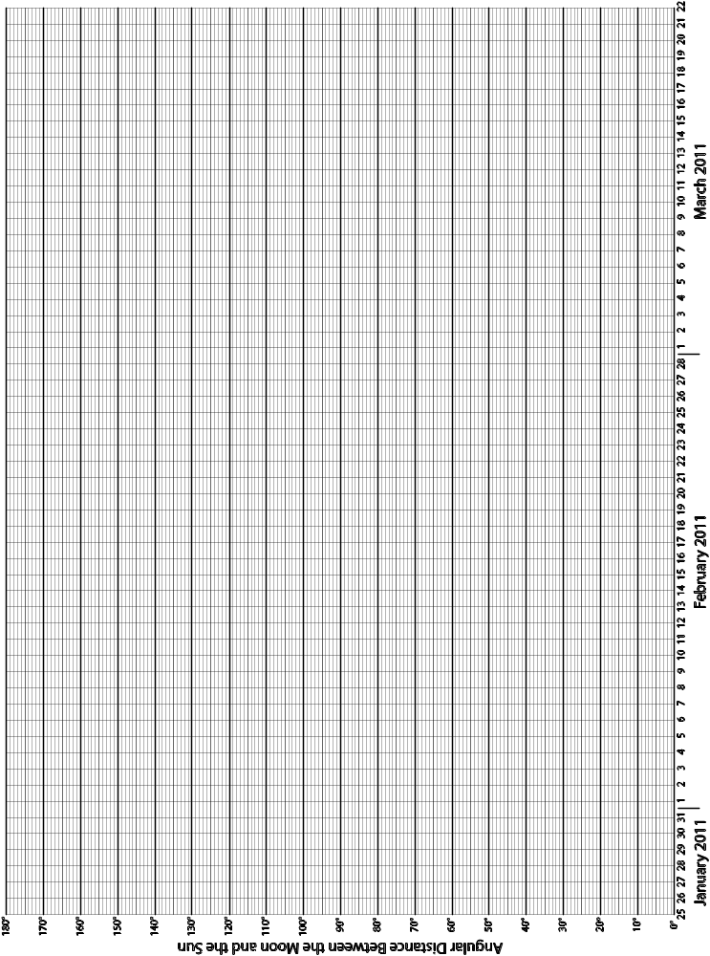
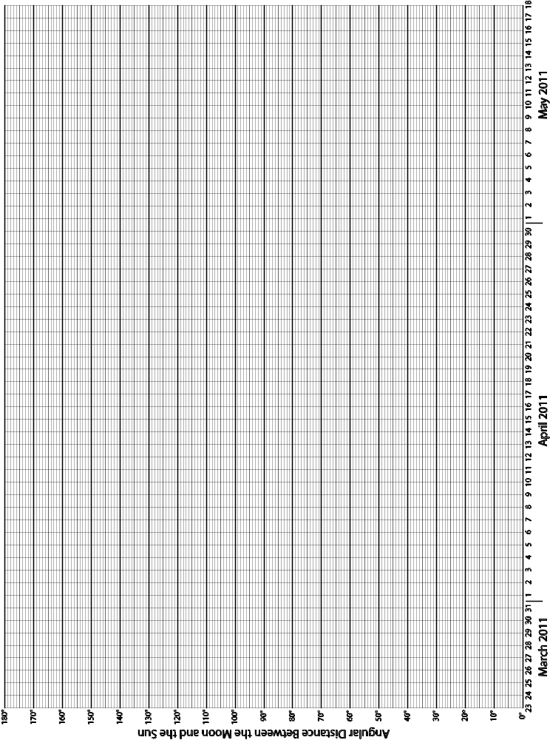
Moon Facts for January 2011

Date | Day of Week | Time of Sunrise | Time of Sunset | Time of Moonrise |  | Time of Moonset
1-Jan | Sa. | 7:28 | 4:53 | 5:07 | AM | 2:34 | PM
2-Jan | Su. | 7:28 | 4:54 | 6:06 | AM | 3:31 | PM
3-Jan | M. | 7:28 | 4:55 | 6:57 | AM | 4:32 | PM
4-Jan | Tu. | 7:28 | 4:56 | 7:40 | AM | 5:35 | PM
5-Jan | W. | 7:28 | 4:57 | 8:16 | AM | 6:38 | PM
6-Jan | Th. | 7:28 | 4:57 | 8:47 | AM | 7:39 | PM
7-Jan | Fr. | 7:28 | 4:58 | 9:14 | AM | 8:39 | PM
8-Jan | Sa. | 7:28 | 4:59 | 9:39 | AM | 9:37 | PM
9-Jan | Su. | 7:28 | 5:00 | 10:03 | AM | 10:34 | PM
10-Jan | M. | 7:27 | 5:01 | 10:27 | AM | 11:32 | PM
11-Jan | Tu. | 7:27 | 5:02 | 10:51 | AM | ∗∗
12-Jan | W. | 7:27 | 5:03 | 11:18 | AM | 12:31 | AM
13-Jan | Th. | 7:27 | 5:05 | 11:49 | AM | 1:31 | AM
14-Jan | Fr. | 7:26 | 5:06 | 12:26 | PM | 2:32 | AM
15-Jan | Sa. | 7:26 | 5:07 | 1:10 | PM | 3:34 | AM
16-Jan | Su. | 7:26 | 5:08 | 2:02 | PM | 4:34 | AM
17-Jan | M. | 7:25 | 5:09 | 3:04 | PM | 5:31 | AM
18-Jan | Tu. | 7:25 | 5:10 | 4:13 | PM | 6:22 | AM
19-Jan | W. | 7:24 | 5:11 | 5:26 | PM | 7:07 | AM
20-Jan | Th. | 7:24 | 5:12 | 6:41 | PM | 7:46 | AM
21-Jan | Fr. | 7:23 | 5:13 | 7:55 | PM | 8:20 | AM
22-Jan | Sa. | 7:22 | 5:15 | 9:09 | PM | 8:51 | AM
23-Jan | Su. | 7:22 | 5:16 | 10:22 | PM | 9:22 | AM
24-Jan | M. | 7:21 | 5:17 | 11:34 | PM | 9:52 | AM
25-Jan | Tu. | 7:20 | 5:18 | ∗ |  | 10:25 | AM
26-Jan | W. | 7:20 | 5:19 | 12:45 | AM | 11:02 | AM
27-Jan | Th. | 7:19 | 5:20 | 1:54 | AM | 11:43 | AM
28-Jan | Fr. | 7:18 | 5:22 | 3:00 | AM | 12:31 | PM
29-Jan | Sa. | 7:17 | 5:23 | 4:00 | AM | 1:24 | PM
30-Jan | Su. | 7:17 | 5:24 | 4:53 | AM | 2:23 | PM
31-Jan | M. | 7:16 | 5:25 | 5:38 | AM | 3:24 | PM

∗ The moon does not rise on this date. It rises early the next day.
∗∗ The moon does not set on this date. It sets early the next day.

Moon Facts for February 2011

Date | Day of Week | Time of Sunrise | Time of Sunset | Time of Moonrise |  | Time of Moonset
1-Feb | Tu. | 7:15 | 5:26 | 6:16 | AM | 4:26 | PM
2-Feb | W. | 7:14 | 5:28 | 6:48 | AM | 5:28 | PM
3-Feb | Th. | 7:13 | 5:29 | 7:17 | AM | 6:28 | PM
4-Feb | Fr. | 7:12 | 5:30 | 7:43 | AM | 7:27 | PM
5-Feb | Sa. | 7:11 | 5:31 | 8:07 | AM | 8:25 | PM
6-Feb | Su. | 7:10 | 5:32 | 8:30 | AM | 9:22 | PM
7-Feb | M. | 7:09 | 5:34 | 8:55 | AM | 10:20 | PM
8-Feb | Tu. | 7:08 | 5:35 | 9:21 | AM | 11:19 | PM
9-Feb | W. | 7:06 | 5:36 | 9:49 | AM | ∗∗
10-Feb | Th. | 7:05 | 5:37 | 10:23 | AM | 12:19 | AM
11-Feb | Fr. | 7:04 | 5:38 | 11:02 | AM | 1:19 | AM
12-Feb | Sa. | 7:03 | 5:39 | 11:49 | AM | 2:18 | AM
13-Feb | Su. | 7:02 | 5:41 | 12:45 | PM | 3:16 | AM
14-Feb | M. | 7:01 | 5:42 | 1:48 | PM | 4:08 | AM
15-Feb | Tu. | 6:59 | 5:43 | 2:59 | PM | 4:55 | AM
16-Feb | W. | 6:58 | 5:44 | 4:13 | PM | 5:37 | AM
17-Feb | Th. | 6:57 | 5:45 | 5:28 | PM | 6:14 | AM
18-Feb | Fr. | 6:55 | 5:46 | 6:44 | PM | 6:48 | AM
19-Feb | Sa. | 6:54 | 5:48 | 8:00 | PM | 7:20 | AM
20-Feb | Su. | 6:53 | 5:49 | 9:16 | PM | 7:52 | AM
21-Feb | M. | 6:51 | 5:50 | 10:30 | PM | 8:25 | AM
22-Feb | Tu. | 6:50 | 5:51 | 11:42 | PM | 9:01 | AM
23-Feb | W. | 6:49 | 5:52 | ∗ |  | 9:42 | AM
24-Feb | Th. | 6:47 | 5:53 | 12:51 | AM | 10:29 | AM
25-Feb | Fr. | 6:46 | 5:54 | 1:54 | AM | 11:21 | AM
26-Feb | Sa. | 6:44 | 5:55 | 2:49 | AM | 12:18 | PM
27-Feb | Su. | 6:43 | 5:57 | 3:37 | AM | 1:18 | PM
28-Feb | M. | 6:42 | 5:58 | 4:17 | AM | 2:20 | PM

∗ The moon does not rise on this date. It rises early the next day.
∗∗ The moon does not set on this date. It sets early the next day.

Moon Facts for March 2011

Date | Day of Week | Time of Sunrise | Time of Sunset | Time of Moonrise |  | Time of Moonset
1-Mar | Tu. | 6:40 | 5:59 | 4:51 | AM | 3:21 | PM
2-Mar | W. | 6:39 | 6:00 | 5:20 | AM | 4:21 | PM
3-Mar | Th. | 6:37 | 6:01 | 5:47 | AM | 5:19 | PM
4-Mar | Fr. | 6:36 | 6:02 | 6:11 | AM | 6:17 | PM
5-Mar | Sa. | 6:34 | 6:03 | 6:35 | AM | 7:15 | PM
6-Mar | Su. | 6:33 | 6:04 | 6:59 | AM | 8:12 | PM
7-Mar | M. | 6:31 | 6:05 | 7:25 | AM | 9:11 | PM
8-Mar | Tu. | 6:29 | 6:06 | 7:53 | AM | 10:10 | PM
9-Mar | W. | 6:28 | 6:07 | 8:24 | AM | 11:09 | PM
10-Mar | Th. | 6:26 | 6:08 | 9:01 | AM | ∗∗
11-Mar | Fr. | 6:25 | 6:09 | 9:44 | AM | 12:08 | AM
12-Mar | Sa. | 6:23 | 6:10 | 10:34 | AM | 1:04 | AM
13-Mar | Su. | 7:22 | 7:12 | 12:32 | PM | 1:57 | AM
14-Mar | M. | 7:20 | 7:13 | 1:37 | PM | 3:45 | AM
15-Mar | Tu. | 7:18 | 7:14 | 2:47 | PM | 4:28 | AM
16-Mar | W. | 7:17 | 7:15 | 4:00 | PM | 5:06 | AM
17-Mar | Th. | 7:15 | 7:16 | 5:15 | PM | 5:41 | AM
18-Mar | Fr. | 7:14 | 7:17 | 6:31 | PM | 6:14 | AM
19-Mar | Sa. | 7:12 | 7:18 | 7:47 | PM | 6:46 | AM
20-Mar | Su. | 7:10 | 7:19 | 9:04 | PM | 7:20 | AM
21-Mar | M. | 7:09 | 7:20 | 10:20 | PM | 7:56 | AM
22-Mar | Tu. | 7:07 | 7:21 | 11:34 | PM | 8:36 | AM
23-Mar | W. | 7:06 | 7:22 | ∗ |  | 9:22 | AM
24-Mar | Th. | 7:04 | 7:23 | 12:42 | AM | 10:14 | AM
25-Mar | Fr. | 7:02 | 7:24 | 1:42 | AM | 11:11 | AM
26-Mar | Sa. | 7:01 | 7:25 | 2:33 | AM | 12:12 | PM
27-Mar | Su. | 6:59 | 7:26 | 3:16 | AM | 1:13 | PM
28-Mar | M. | 6:58 | 7:27 | 3:52 | AM | 2:15 | PM
29-Mar | Tu. | 6:56 | 7:28 | 4:23 | AM | 3:15 | PM
30-Mar | W. | 6:54 | 7:29 | 4:50 | AM | 4:13 | PM
31-Mar | Th. | 6:53 | 7:30 | 5:16 | AM | 5:11 | PM

∗ The moon does not rise on this date. It rises early the next day.
∗∗ The moon does not set on this date. It sets early the next day.

Moon Facts for April 2011

Date | Day of Week | Time of Sunrise | Time of Sunset | Time of Moonrise |  | Time of Moonset
1-Apr | Fr. | 6:51 | 7:31 | 5:40 | AM | 6:09 | PM
2-Apr | Sa. | 6:50 | 7:32 | 6:04 | AM | 7:06 | PM
3-Apr | Su. | 6:48 | 7:33 | 6:29 | AM | 8:04 | PM
4-Apr | M. | 6:46 | 7:34 | 6:56 | AM | 9:03 | PM
5-Apr | Tu. | 6:45 | 7:35 | 7:27 | AM | 10:02 | PM
6-Apr | W. | 6:43 | 7:36 | 8:02 | AM | 11:01 | PM
7-Apr | Th. | 6:42 | 7:37 | 8:43 | AM | 11:58 | PM
8-Apr | Fr. | 6:40 | 7:38 | 9:31 | AM | ∗∗
9-Apr | Sa. | 6:39 | 7:39 | 10:25 | AM | 12:51 | AM
10-Apr | Su. | 6:37 | 7:40 | 11:26 | AM | 1:40 | AM
11-Apr | M. | 6:36 | 7:41 | 12:32 | PM | 2:23 | AM
12-Apr | Tu. | 6:34 | 7:42 | 1:41 | PM | 3:02 | AM
13-Apr | W. | 6:32 | 7:43 | 2:52 | PM | 3:37 | AM
14-Apr | Th. | 6:31 | 7:44 | 4:05 | PM | 4:09 | AM
15-Apr | Fr. | 6:29 | 7:45 | 5:19 | PM | 4:41 | AM
16-Apr | Sa. | 6:28 | 7:46 | 6:35 | PM | 5:13 | AM
17-Apr | Su. | 6:27 | 7:47 | 7:51 | PM | 5:48 | AM
18-Apr | M. | 6:25 | 7:48 | 9:08 | PM | 6:26 | AM
19-Apr | Tu. | 6:24 | 7:49 | 10:20 | PM | 7:10 | AM
20-Apr | W. | 6:22 | 7:50 | 11:26 | PM | 8:01 | AM
21-Apr | Th. | 6:21 | 7:51 | ∗ |  | 8:58 | AM
22-Apr | Fr. | 6:19 | 7:52 | 12:23 | AM | 9:59 | AM
23-Apr | Sa. | 6:18 | 7:53 | 1:11 | AM | 11:03 | AM
24-Apr | Su. | 6:17 | 7:54 | 1:51 | AM | 12:06 | PM
25-Apr | M. | 6:15 | 7:55 | 2:24 | AM | 1:07 | PM
26-Apr | Tu. | 6:14 | 7:56 | 2:53 | AM | 2:07 | PM
27-Apr | W. | 6:13 | 7:57 | 3:19 | AM | 3:05 | PM
28-Apr | Th. | 6:11 | 7:58 | 3:43 | AM | 4:02 | PM
29-Apr | Fr. | 6:10 | 7:59 | 4:08 | AM | 4:59 | PM
30-Apr | Sa. | 6:09 | 8:00 | 4:33 | AM | 5:57 | PM

∗ The moon does not rise on this date. It rises early the next day.
∗∗ The moon does not set on this date. It sets early the next day.

Moon Facts for May 2011

Date | Day of Week | Time of Sunrise | Time of Sunset | Time of Moonrise |  | Time of Moonset
1-May | Su. | 6:08 | 8:01 | 4:59 | AM | 6:56 | PM
2-May | M. | 6:06 | 8:02 | 5:29 | AM | 7:55 | PM
3-May | Tu. | 6:05 | 8:03 | 6:03 | AM | 8:55 | PM
4-May | W. | 6:04 | 8:04 | 6:42 | AM | 9:53 | PM
5-May | Th. | 6:03 | 8:05 | 7:28 | AM | 10:48 | PM
6-May | Fr. | 6:02 | 8:06 | 8:21 | AM | 11:38 | PM
7-May | Sa. | 6:00 | 8:07 | 9:20 | AM | ∗∗
8-May | Su. | 5:59 | 8:08 | 10:24 | AM | 12:22 | AM
9-May | M. | 5:58 | 8:09 | 11:31 | AM | 1:02 | AM
10-May | Tu. | 5:57 | 8:10 | 12:39 | PM | 1:37 | AM
11-May | W. | 5:56 | 8:11 | 1:49 | PM | 2:09 | AM
12-May | Th. | 5:55 | 8:12 | 2:59 | PM | 2:40 | AM
13-May | Fr. | 5:54 | 8:13 | 4:12 | PM | 3:10 | AM
14-May | Sa. | 5:53 | 8:14 | 5:26 | PM | 3:43 | AM
15-May | Su. | 5:52 | 8:14 | 6:41 | PM | 4:18 | AM
16-May | M. | 5:51 | 8:15 | 7:55 | PM | 4:59 | AM
17-May | Tu. | 5:51 | 8:16 | 9:05 | PM | 5:46 | AM
18-May | W. | 5:50 | 8:17 | 10:07 | PM | 6:41 | AM
19-May | Th. | 5:49 | 8:18 | 11:01 | PM | 7:41 | AM
20-May | Fr. | 5:48 | 8:19 | 11:45 | PM | 8:46 | AM
21-May | Sa. | 5:47 | 8:20 | ∗ |  | 9:51 | AM
22-May | Su. | 5:47 | 8:21 | 12:22 | AM | 10:54 | AM
23-May | M. | 5:46 | 8:22 | 12:53 | AM | 11:56 | AM
24-May | Tu. | 5:45 | 8:22 | 1:21 | AM | 12:55 | PM
25-May | W. | 5:45 | 8:23 | 1:46 | AM | 1:53 | PM
26-May | Th. | 5:44 | 8:24 | 2:10 | AM | 2:51 | PM
27-May | Fr. | 5:43 | 8:25 | 2:35 | AM | 3:48 | PM
28-May | Sa. | 5:43 | 8:26 | 3:01 | AM | 4:47 | PM
29-May | Su. | 5:42 | 8:26 | 3:30 | AM | 5:46 | PM
30-May | M. | 5:42 | 8:27 | 4:02 | AM | 6:46 | PM
31-May | Tu. | 5:41 | 8:28 | 4:40 | AM | 7:45 | PM

∗ The moon does not rise on this date. It rises early the next day.
∗∗ The moon does not set on this date. It sets early the next day.

Mary Barrett is a school teacher in Berkeley, CA. This poem appeared in the Fall/Winter 1999 GEMS Network News. If you plan to teach elementary or junior high school, check out all the wonderful GEMS (Great Explorations in Math and Science) K–8 teacher’s guides in math and science at http://www.lhs.berkeley.edu/gems/gems.html.

